In a study examining the relation of math ability to belief that math ability was innate, belief was considered the predictor variable. The scores for participants are shown below:

|  |  |
| --- | --- |
| Math Ability | Belief that math ability is innate |
| 66 | 7 |
| 70 | 4 |
| 50 | 10 |
| 45 | 12 |
| 57 | 6 |
| 65 | 6 |

1. Make a scatter plot of the scores.
2. Describe the pattern of association.
3. Use the six steps of hypothesis testing to determine if there is a significant relationship between math ability and innateness belief, using the p <.05 criterion.

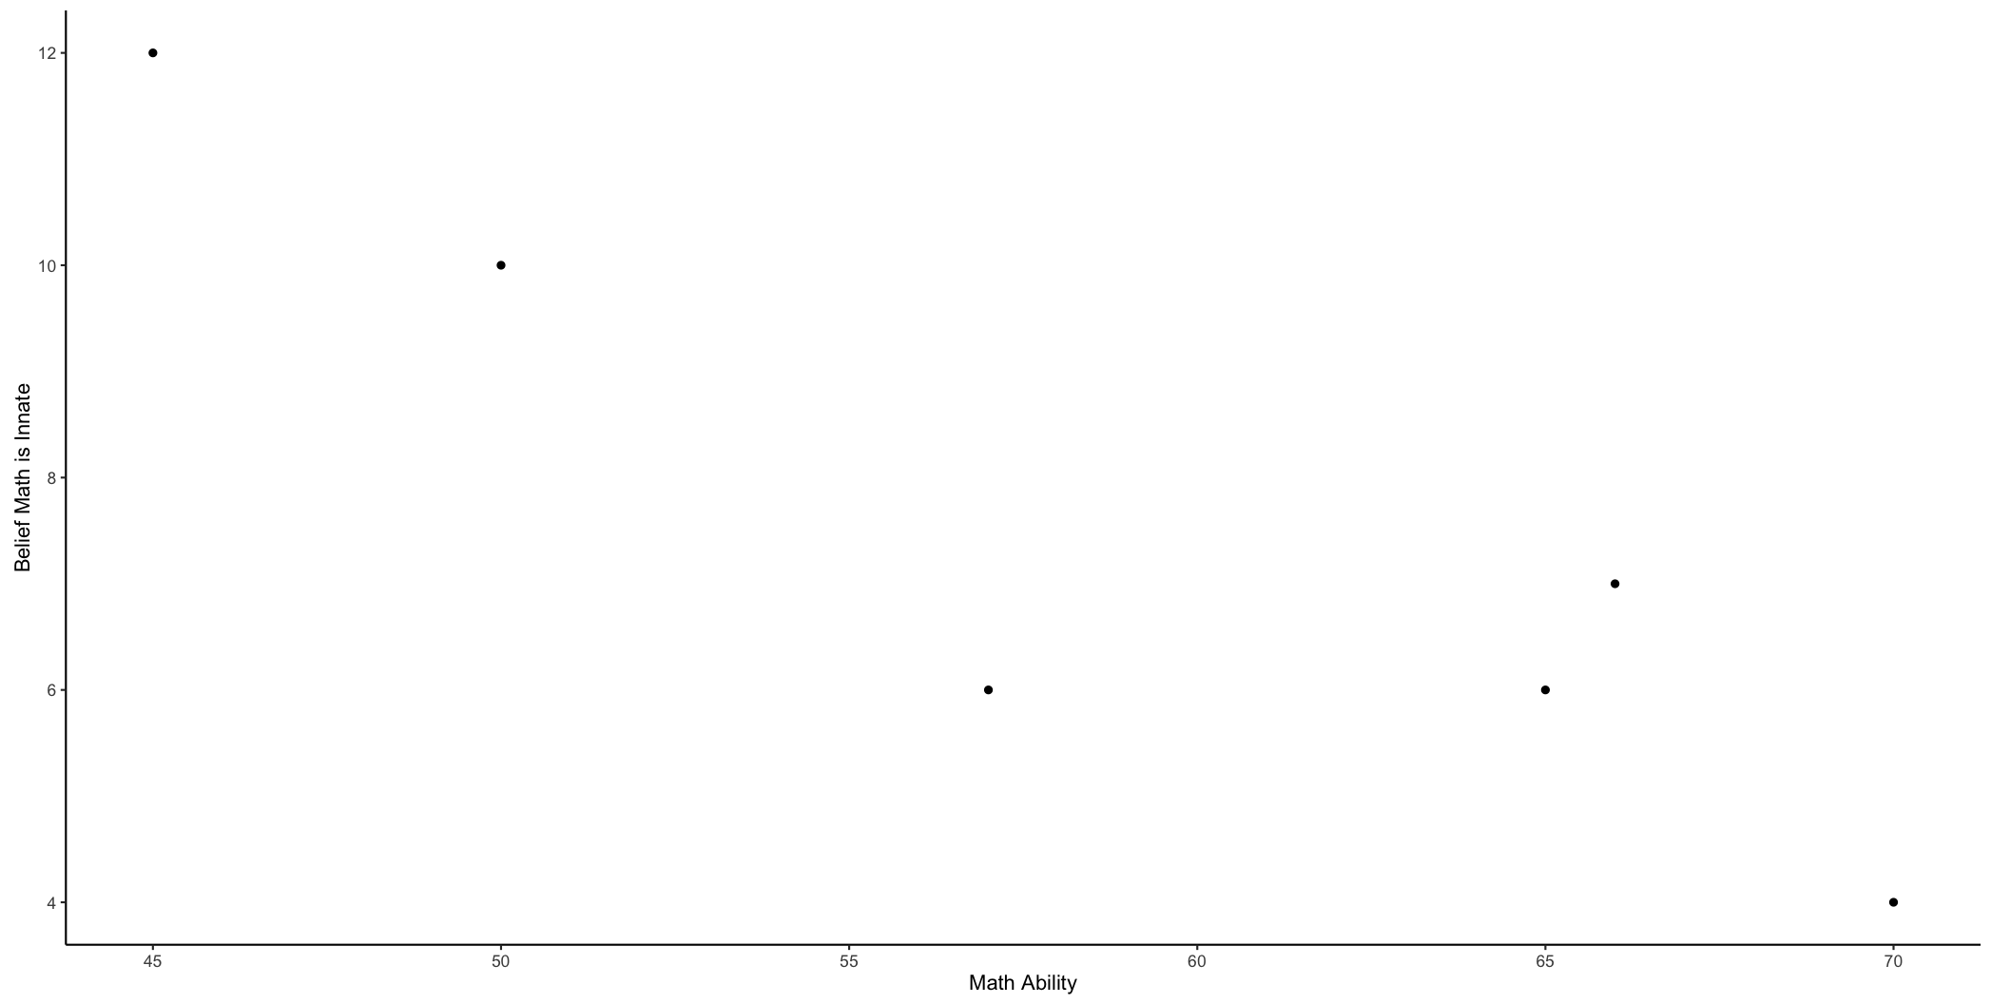

Negative correlation

Step 1:

X and Y are scale – at least interval yes

X and Y are normal – no N < 30

Random selection – no, random assignment – no

Homoscedasticity – yes

Step 2:

R: math and belief are correlated r / = 0

N: math are belief are not correlated r = 0

Step 3:

r = - .91

df = 4

Pearson's product-moment correlation

data: correlation$math and correlation$belief

t = -4.6096, df = 4, p-value = 0.009959

alternative hypothesis: true correlation is not equal to 0

95 percent confidence interval:

-0.9910749 -0.4141489

sample estimates:

cor

-0.9173741

Step 4:

T critical = + and – 2.78

Step 5:

t found = -4.6096

Step 6:

Reject the null – there is a correlation between math and belief

A cognitive psychology conducted a study of whether familiarity of words predicts the time it takes to press a button indicating whether a word is singular or plural. All participants were given the same words. Familiarity with words was rated at a later time on a 7 point scale (high = familiar), and the scores are listed below.

|  |  |
| --- | --- |
| Familiarity | Response Time |
| 6 | 1.25 |
| 2 | 3.16 |
| 3 | 2.84 |
| 4 | 2.05 |
| 5 | 1.75 |
| 6 | 1.04 |
| 3 | 2.25 |

Using X to predict Y

X should predict Y

Y is predicted by X

X familiarity

Y response time

1. Write out the regression equation.
2. Does familiarity predict response time? Write out the six steps to hypothesis testing using the p < .05 level.
3. Predict the response time for a person who rates familiarity as a 5.
4. Include a scatter plot.

Coefficients:

Estimate Std. Error t value Pr(>|t|)

(Intercept) 4.03635 0.24219 16.67 1.42e-05 ***

Familiarity -0.47981 0.05515 -8.70 0.000332 ***

---

Signif. codes: 0 ‘***’ 0.001 ‘**’ 0.01 ‘*’ 0.05 ‘.’ 0.1 ‘ ’ 1

Residual standard error: 0.2126 on 5 degrees of freedom

Multiple R-squared: 0.938, Adjusted R-squared: 0.9256

F-statistic: 75.69 on 1 and 5 DF, p-value: 0.000332

Y = 4.04 – 0.48X

Y = 4.04 - .48*5

Y = 1.64

Step 1:

X and Y are scale = yes, interval and one is ratio

X and Y are normal = No, N < 30

Random selection: no, random assignment: no

Homoscedasticity: yes

Step 2:

R: Familiarity predict response time b =/ 0

N: Familiarity does not predict response times b = 0

Step 3:

Coefficients:

Estimate Std. Error t value Pr(>|t|)

(Intercept) 4.03635 0.24219 16.67 1.42e-05 ***

Familiarity -0.47981 0.05515 -8.70 0.000332 ***

---

Signif. codes: 0 ‘***’ 0.001 ‘**’ 0.01 ‘*’ 0.05 ‘.’ 0.1 ‘ ’ 1

Residual standard error: 0.2126 on 5 degrees of freedom

Multiple R-squared: 0.938, Adjusted R-squared: 0.9256

F-statistic: 75.69 on 1 and 5 DF, p-value: 0.000332

Beta:

Familiarity

-0.968522

df = 5

Step 4:

T critical = + and – 2.57

Step 5:

T found = -8.70

Step 6:

Yes reject the null

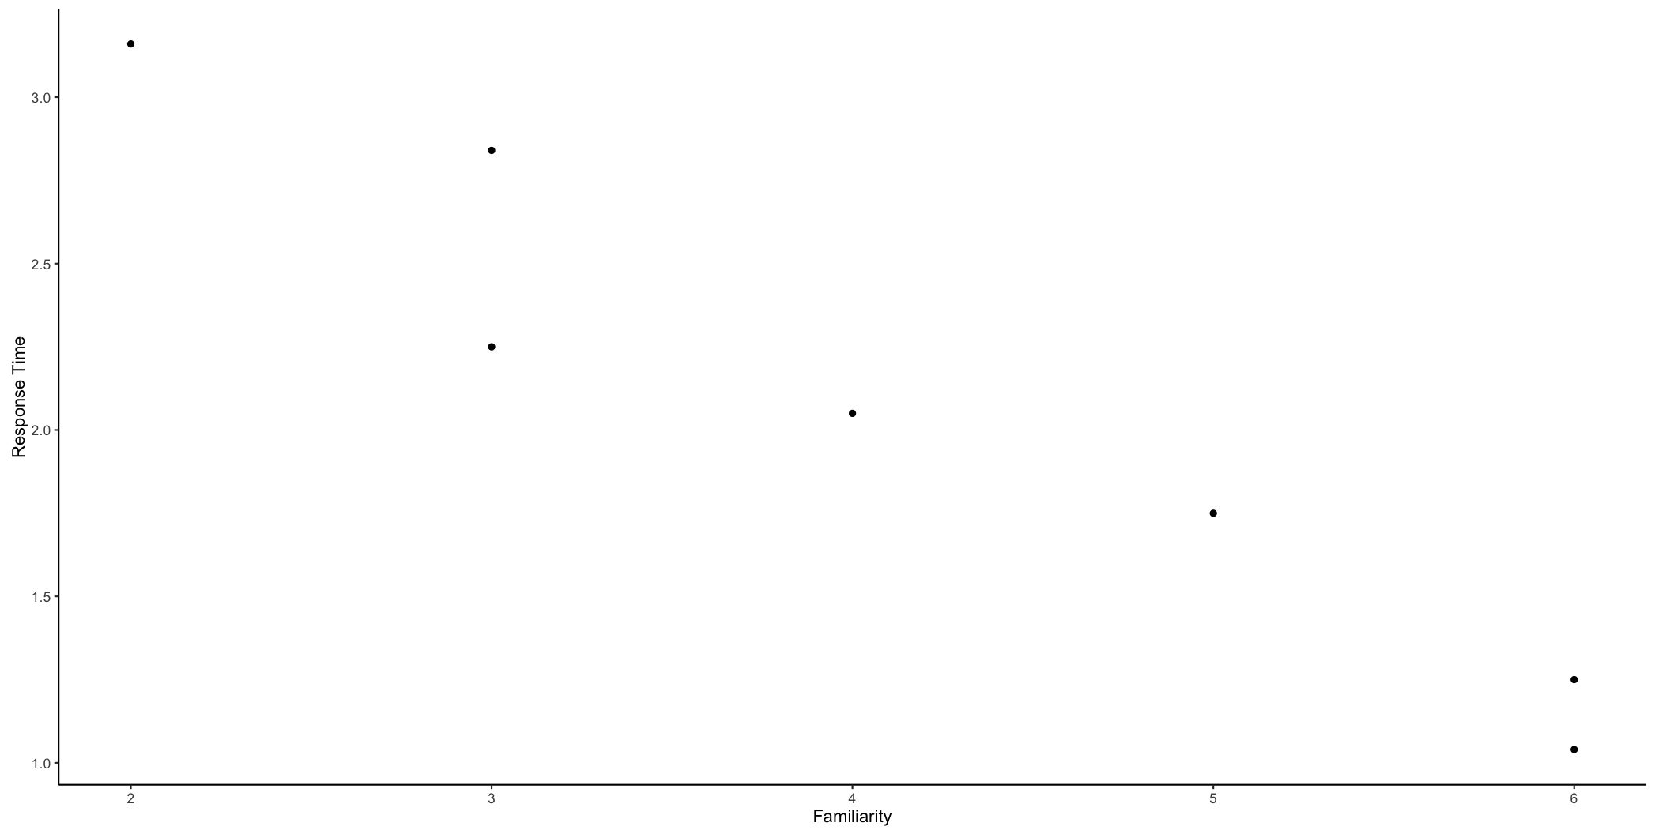

You can add the line if you want:

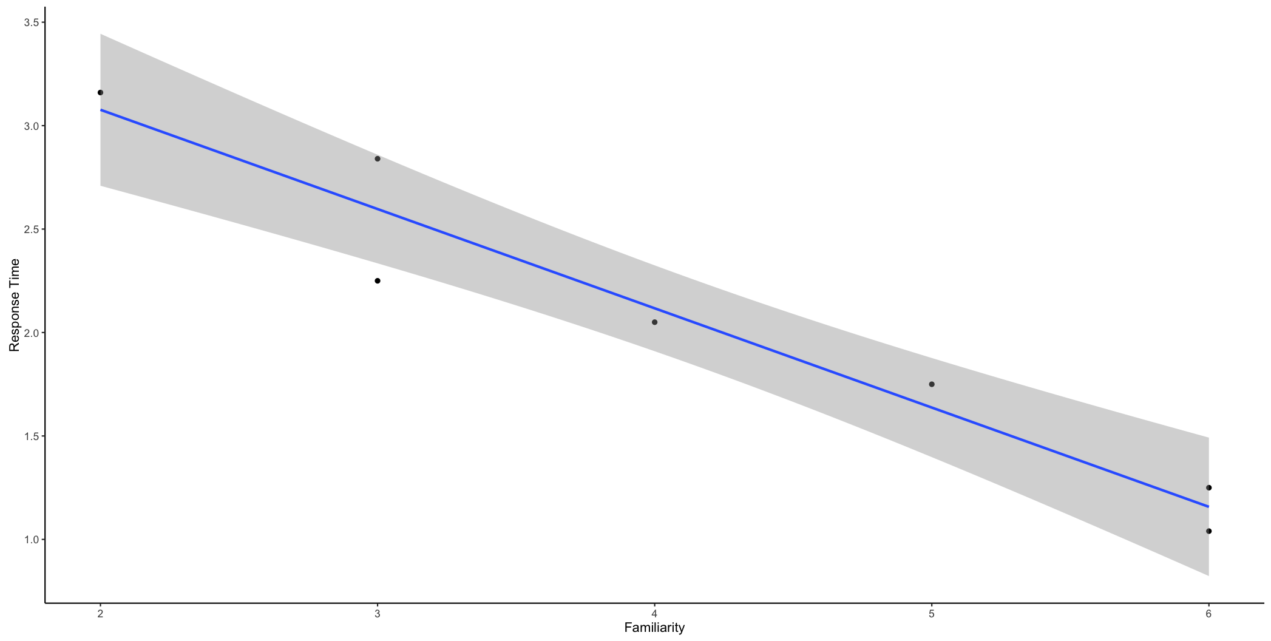

Word ratings can be predicted by how well we can type them on the computer (similar to the so called QWERTY effect). However, it is also important to control for word and letter frequency, as those predict our ratings as well. Using *p* < .05, which predictor seems to be the best?

|  |  |  |  |
| --- | --- | --- | --- |
| Letter Frequency | Word Frequency | Typing Speed | Rating |
| 4.69 | 7.51 | 58.92 | 3.27 |
| 3.55 | 7.80 | 61.24 | 2.91 |
| 5.25 | 7.12 | 59.71 | 2.79 |
| 3.25 | 5.65 | 58.50 | 2.62 |
| 3.38 | 6.22 | 60.00 | 1.89 |
| 3.67 | 5.80 | 61.13 | 2.71 |
| 3.64 | 5.85 | 59.70 | 2.54 |
| 4.85 | 5.59 | 61.96 | 2.24 |
| 4.30 | 6.26 | 59.07 | 2.50 |
| 5.20 | 5.65 | 61.06 | 2.78 |
| 4.87 | 7.08 | 59.78 | 2.82 |
| 5.01 | 5.53 | 59.02 | 3.09 |
| 4.58 | 4.98 | 61.63 | 2.09 |
| 3.09 | 6.70 | 61.19 | 3.18 |
| 4.00 | 6.16 | 58.16 | 2.99 |

1. Write out the regression equation predicting rating with letter frequency, word frequency, and typing speed.
2. Include the beta values.
3. Write out the six steps to hypothesis testing using the p < .05 level.
4. Include a scatter plot.

Coefficients:

Estimate Std. Error t value Pr(>|t|)

(Intercept) 6.07335 5.01007 1.212 0.2508

Letter.Frequency 0.06673 0.12871 0.518 0.6144

Word.Frequency 0.23163 0.11971 1.935 0.0791 .

Typing.Speed -0.08507 0.08028 -1.060 0.3120

---

Signif. codes: 0 ‘***’ 0.001 ‘**’ 0.01 ‘*’ 0.05 ‘.’ 0.1 ‘ ’ 1

Residual standard error: 0.3608 on 11 degrees of freedom

Multiple R-squared: 0.3419, Adjusted R-squared: 0.1624

F-statistic: 1.905 on 3 and 11 DF, p-value: 0.1874

Y = 6.07 + .07(letter frequency) + .23(word frequency) - .09(typing speed)

Letter.Frequency Word.Frequency Typing.Speed

0.1269974 0.4787352 -0.2619210

Step 1:

Xs and Y are scale – yes, at least interval

X and Y are normal – no N < 30

Random selection: no, randomly assign: no

Homoscedasticity: yes pretty good

Step 2:

R: letter frequency, word frequency, and typing speed will predict ratings bs =/0

N: letter frequency, word frequency, and typing speed will not predict ratings bs = 0

Step 3:

Coefficients:

Estimate Std. Error t value Pr(>|t|)

(Intercept) 6.07335 5.01007 1.212 0.2508

Letter.Frequency 0.06673 0.12871 0.518 0.6144

Word.Frequency 0.23163 0.11971 1.935 0.0791 .

Typing.Speed -0.08507 0.08028 -1.060 0.3120

---

Signif. codes: 0 ‘***’ 0.001 ‘**’ 0.01 ‘*’ 0.05 ‘.’ 0.1 ‘ ’ 1

Residual standard error: 0.3608 on 11 degrees of freedom

Multiple R-squared: 0.3419, Adjusted R-squared: 0.1624

F-statistic: 1.905 on 3 and 11 DF, p-value: 0.1874

Letter.Frequency Word.Frequency Typing.Speed

0.1269974 0.4787352 -0.2619210

df = 11

Step 4:

T critical = + and – 2.20

Step 5:

Letter frequency t = .52

Word frequency t = 1.94

Typing speed t = -1.06

Step 6:

Fail to reject the null for all predictors

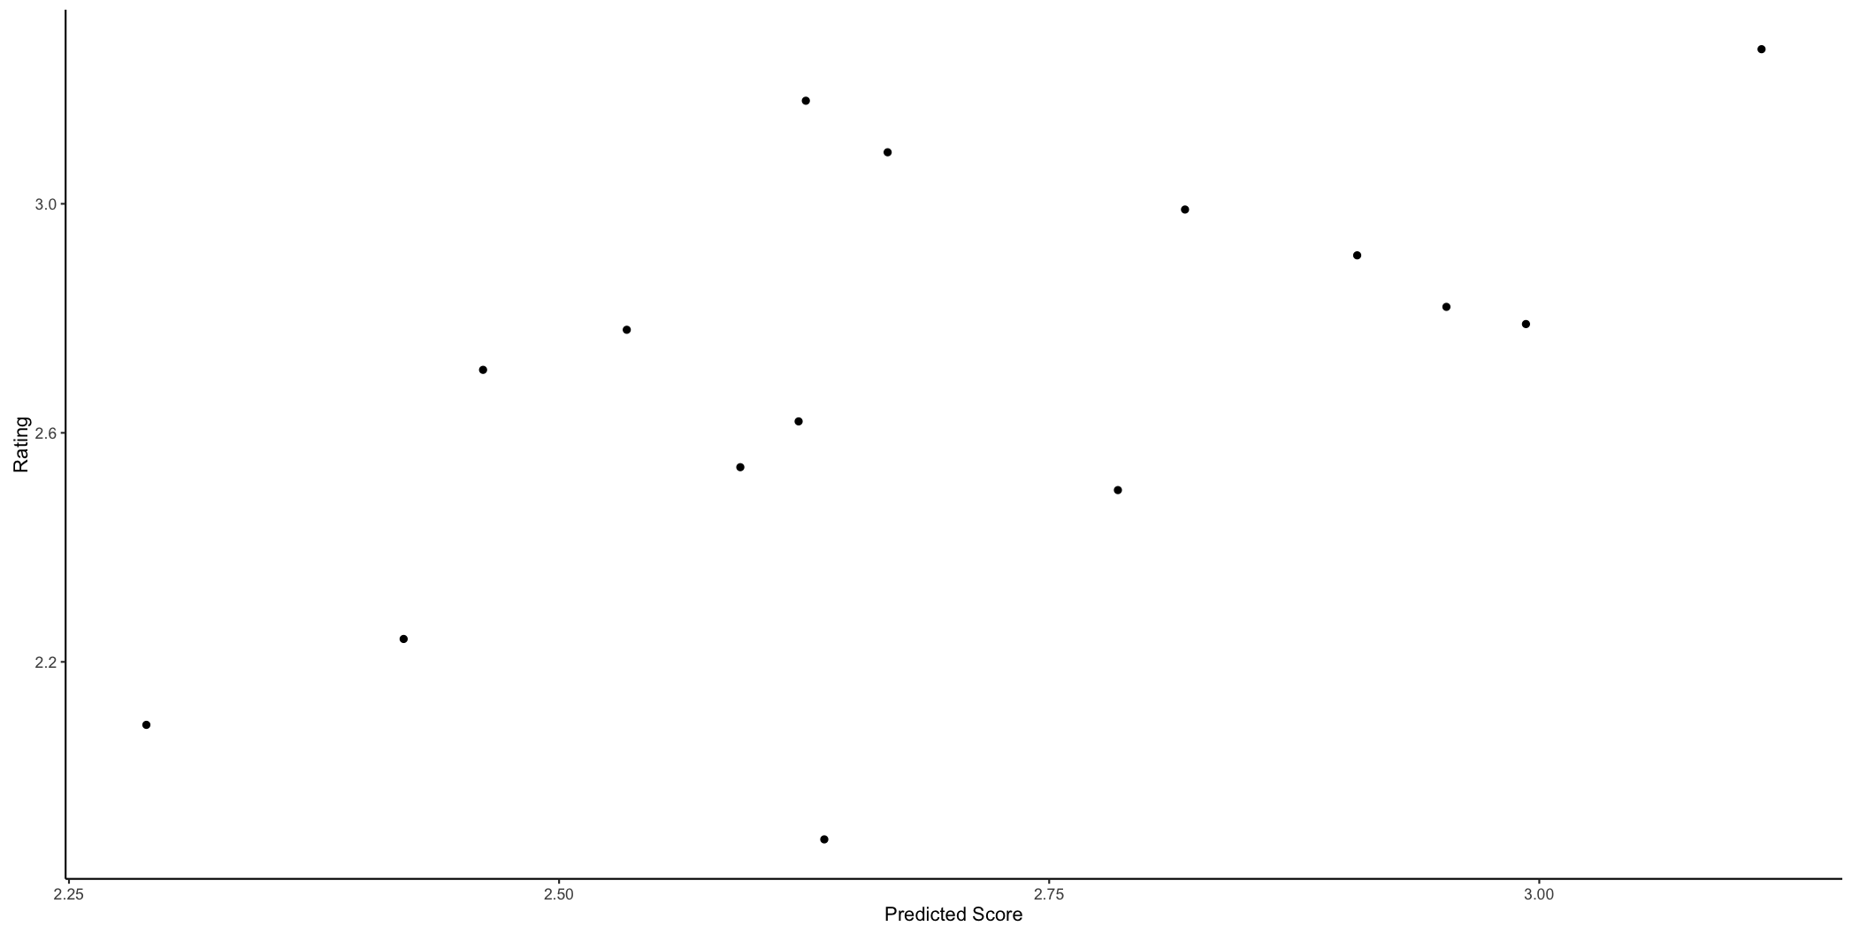

You can also add the line (either plot is fine).

